

Frequently Asked Questions

# How do I get to the venue?

**Train** – The venue is in close proximity to Leeds Train Station (0.8 miles) with direct train services from all major cities. UKREiiF staff in red uniform at the station will be able to assist you with any queries.

Please visit the [National Rail](https://www.nationalrail.co.uk/) website for more details.

**Park and Ride** - There are three park and ride sites in Leeds, with Elland Road for trips from the south and west of Leeds, Temple Green if you’re coming from the north or east, and Stourton if travelling into the south or south west of the city. These provide an ideal alternative to finding city centre parking with buses running every 10-15 minutes

**Walking –** It’s about a 15-20 minute walk from Leeds City Centre or the South Exit of Leeds Train Station. Just follow the event signs or check out the suggested walking routes on the map linked [here](https://www.google.com/maps/d/u/0/viewer?mid=1xBqnvADxtNBBCC_1i29cHEk-FnhA2YQ&ll=53.793746251086006%2C-1.540557999999983&z=13). You’ll also spot friendly Wayfinders along the route between 8am and 10am each morning if you need a hand or directions.

View the wayfinding map [here](https://www.ukreiif.com/content/uploads/sites/3/2025/05/UKREiiF-Map_2025-D2.pdf).

**Car** – The closest car park is [CitiPark](https://citipark.co.uk/car-parks/leeds/clarence-leeds-dock) at New Dock where you can prebook parking at a discounted rate. To do so, book [via the website](https://book.citipark.co.uk/?utm_campaign=13153007_UKREiiF%20Speaker%20Comms%201%20LS&utm_medium=email&utm_source=Built%20Environment%20Networking&dm_t=0%2C0%2C0%2C0%2C0) for a minimum of 13 hours for the discount to apply; you don’t have to stay for the full duration. Use code **LDOCK8** at checkout to avail a discounted price of £8.06.

**Water Taxi -** Drop off point is at the dockside on the event site. Exit Leeds Train Station via the New South Entrance. The water taxis are every 12 minutes and can carry up to 8 passengers at a time; situated on the lower water level, costing £2 per journey, per person. If you are not in the train station, best access for water taxi is by taking the bridge at the end of Little Neville Street. Live tracking information [here](https://ddlnk.net/t/1VDN-7U2LG-2E9XLB-4S0R7E-1/c.aspx).

**Cycling –** You can cycle to UKREiiF. There are dedicated cycle storage facilities throughout the venue. If you are travelling from Oxford and Edinburgh, you can join [Club Peloton’s](https://clubpeloton.org/events/156973) cycling event and join other delegates who are cycling together to attend UKREiiF.

**Shuttle bus** - Provided by West Yorkshire Combined Authority, First Bus are offering a free sustainable and stress-free shuttle service to UKREiiF. Hop on our dedicated shuttle, running at 07:30-10:30 and 15:45-17:15 between Leeds Station and the event venue at Leeds Dock, an easy and eco-conscious way to get to us. Here’s how to catch the UKREiiF Sustainable Shuttle Bus:

Exit Leeds Station via the South Entrance (located near platforms 16–17 on the upper floor).

* Take the escalators or lift down to street level.
* Cross Unity Bridge onto Little Neville Street.
* Head to Station F Bus Stop, directly opposite the Hilton Hotel.
* The shuttle will drop you just a short walk from Leeds Dock. Follow signage for nearest event entrance.

View the Leeds interactive map [here](https://www.google.com/maps/d/u/0/viewer?mid=1xBqnvADxtNBBCC_1i29cHEk-FnhA2YQ&ll=53.79374625108598%2C-1.540557999999983&z=13), and wayfinding map [here](https://www.ukreiif.com/content/uploads/sites/3/2025/05/UKREiiF-Map_2025-D2.pdf).

# How can I get my badge?

To complete your registration, please upload your photo and postal address on our registration site. Following this step, **your badge will be posted out to you on w/c 12 May 2025**. You need to bring this badge and supplied lanyard with you to gain access to the event.

**Please ensure** [**ukreiif@ecreg.uk**](mailto:ukreiif@ecreg.uk) **email is marked as “not spam” on your email**

**folders, to ensure you receive all relevant communications.**

If you have registered to attend after 11th April, or if you are an international delegate, you will be able to pick your badge up in person from Pre-Registration (see below for details) or on site during live event from 7:30am onwards. You will be asked to show your email confirmation booking to security at our entry gates.

# I missed the deadline to upload my photo and postal address, how do I get my badge?

You can collect your badge at either **Pre-Registration** (information below) on Monday 19th May 3pm-7.30pm or during **live event** days, following the completion of your photo upload. This photo upload will generate a QR code for badge collection. Photo is printed on your badge, which needs to be worn at all times during UKREiiF.

**Pre-Registration**

Pre-registration and badge collection is available at [The Queens Hotel](https://ddlnk.net/t/1VDN-7TA6P-2E9XLB-4RLDJ6-1/c.aspx).

**Monday,** 19 May 2025

**Time**: 15:30– 19:00

**Venue**: Queens Hotel, New Station Street City Square, Leeds LS1 1PJ

**Room**: Palm Court

**Badge collection during live event:**

**Location**: New Dock Hall Foyer, Armouries Drive, LS10 1LT Days: **Tuesday** 20 May 2025 – from 07:30am to 7:30pm **Wednesday** 21 May 2025 – from 07:30am to 7:30pm **Thursday** 22 May 2025 – from 07:30am to midday

# I can no longer make it; can my colleague attend instead?

To change a delegate name, please email [ukreiif.info@ukreiif.com](mailto:ukreiif.info@ukreiif.com) with details of new delegates and the team will action for you within 48 hours. Share their name, email address, mobile number and job title for the change.

**Deadline for any delegate change is 28 March 2025**

# I have booked my ticket but cannot access the delegate directory.

You will be given access to delegate directory within 48 hours of booking your ticket or confirming your name on the Cvent attendee portal. If you haven’t received your login details, you can access this signing in below and following steps as prompted.

Link: <https://2025.ukreiif.com/en>

If you still cannot access, then please email [ukreiif.info@ukreiif.com](mailto:ukreiif.info@ukreiif.com) clearly stating your query.

# Can I buy food and beverage at the event?

Food & Beverage is available to purchase all day from various local vendors and pop ups in the Lime Zone. Vegetarian, Vegan and Halal options on offer.

Alcohol is available to purchase after 3:00pm in various ‘pop-up’ outlets throughout

the event footprint.

# What arrangements do you have for meeting spaces and quiet spaces at the event?

There are F&B points, indoor café stations, and meeting spaces dotted around the UKREiiF site where delegates can sit down for meetings, chats and utilise quiet spaces.

There is also a quiet room reserved for our delegates in the Royal Armouries Museum building. Ask one of our friendly event staff and they will point you in the right direction.

# Does the event have any cloakroom facilities?

There is a ticketed and staffed cloakroom available to all delegates on the ground floor of Holiday Inn (purple zone), next to New Dock Hall registration area. Please be advised that all items are left at delegates’ discretion and is not the responsibility of the event organiser/ venue, therefore we advise against storing any valuables. Due to limited space in the cloakroom, we encourage you to leave your belongings at your hotel if possible.

# Will I be able to get online?

There is delegate Wi-Fi, provided by Greystar. The password to access the Wi-Fi is **Greystar2025!**

# Are there toilets and baby change facilities available on site?

Toilets are available in New Dock Hall foyer, 1st,2nd and 4th floor of Royal Armouries and ground floor of Holiday Inn. You will find male, female, and disabled toilets in the Royal Armouries as well as New Dock Hall.

Baby change is on 1st and 2nd floor of Royal Armouries.

# Is there a faith room?

A faith room is allocated at Department, The Boulevard, Yellow Zone

# I don’t have a ticket to UKREiiF. Can I still attend?

If you have not booked your tickets but want to attend UKREiiF, you are able to register and purchase a ticket on arrival at New Dock Hall Foyer. However, it is advised to book your tickets in advance to avoid queues and guaranteed entry.

# What else is on offer at UKREiiF, in addition to the programme on the website?

There are several ‘fringe events’ being hosted across Leeds city by our event partners. To make the most of your attendance at UKREiiF, it is highly recommended to attend as many ancillary events as possible. More details can be found [here](https://2025.ukreiif.com/programme).

# What can I access across the site with a UKREiiF ticket?

Everything can be accessed other than those programme items/fringe events marked as invite only. If any fringe events require pre-registration, then delegates must do so first otherwise entry is not guaranteed.

# Where can I book my accommodation?

There are many hotels and places to stay across the city of Leeds as well as locations like Colton, Garforth, Rothwell and Hunslet, which are on the edge of the city – whilst cities like Wakefield are just a 15-minute train or drive away. Bradford, Harrogate, York and Huddersfield are also great options with good transport links.

Accommodation can be booked here:

[Hotels with easy transport links](https://book.passkey.com/event/50890009/owner/9564921/home) [Hotel Planner](https://accommodation.ukreiif.com/)

[Event Stays by Conference Care](https://www.ukreiif.com/event/ukreiif-annual-event-2025/#%3A~%3Atext%3DCONFERENCE%20CARE%20HOTEL%20BOOKING%20%3E)

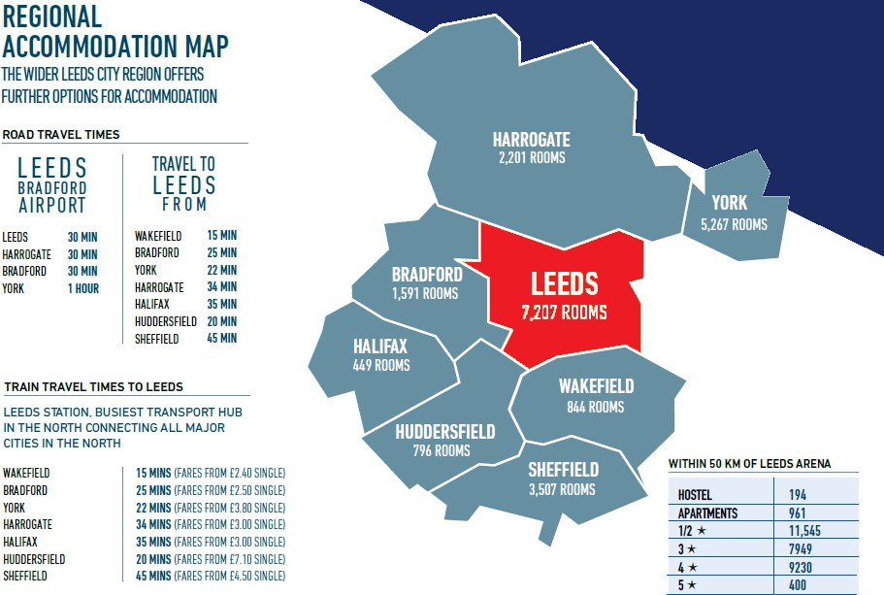

# What’s happening at UKREiiF?

We have an exciting and engaging programme of events scheduled for UKREiiF. Please [click here](https://2025.ukreiif.com/en/programme) to view the full programme.

# Is the event sustainable?

Sustainability is at the core of our planning, and we have been mindful of our environmental impact at every stage of UKREiiF. We have ensured responsible energy usage, no waste going to landfill, promoting sustainable travel and many more activities which makes UKREiiF sustainable. This is more important than ever as we are to ISO20121 accredited and want to ensure we maintain this high standard.

Below are some key highlights, more information can be found [here](https://www.ukreiif.com/net-zero-agenda-2/).

* + Our lanyards are made of recycled PET material.
  + Lanyards are repurposed by a local charity for community events and arts/crafts.
  + All pavilions are fuelled by HVO diesel.
  + There is a Sustainability Champion Initiative where we recognize our partners who have gone the extra mile with their sustainability efforts at UKREiiF.

# What essential items should I carry?

* It is advisable to bring a power bank to charge your mobile throughout the day
* Please wear weather appropriate clothing due to some parts of the event being outdoors
* Wear comfortable shoes and your badge and lanyard at all times

# Do you have any floor plans/site maps?

Our programme is coloured by areas relating to the below map. Available on the website. Once on-site, there will be a map of the exhibition halls in the printed programme and all UKREiiF event staff in red tops will be able to help/point delegates in the right direction.

Link to view map is [here](https://mobicheckin-assets.s3.eu-west-1.amazonaws.com/uploads/events/670cfa0ac818b2d201d19999/website/assets-folder674eff974e0e324be2b92371/Map_5bfdd2c3-cf80-4d85-a672-7ca562b23f0e.jpg)

